Propositional & Predicate Logics
Marius Steller Imingen

1.1
a)
A | B | ¬B | A∧¬B | A∨B
1 | 1 | 0 | 0 | 1
1 | 0 | 1 | 1 | 1
0 | 1 | 0 | 0 | 1
0 | 0 | 1 | 0 | 0

A∧¬B |= A∨B = True

b)

A | B | ¬B | A∧¬B | A∨B
1 | 1 | 0 | 0 | 1
1 | 0 | 1 | 1 | 1
0 | 1 | 0 | 0 | 1
0 | 0 | 1 | 0 | 0

A∨B |= A∧¬B = False

c)

A | B | A ⇔ B | A ⇒ B
1 | 1 | 1 | 1
1 | 0 | 0 | 0
0 | 1 | 0 | 1
0 | 0 | 1 | 1

A ⇔ B |= A ⇒ B = True

d)

A | B | ¬ B | C | ¬C | A ⇔B | (A ⇔B) ⇔C | A∨¬B | A∨¬B∨¬C
1 | 1 | 0 | 0 | 1 | 1 | 0 | 1 | 1
1 | 0 | 1 | 0 | 1 | 0 | 1 | 1 | 1
0 | 1 | 0 | 0 | 1 | 0 | 1 | 0 | 0
0 | 0 | 1 | 0 | 1 | 1 | 0 | 1 | 1
1 | 1 | 0 | 1 | 0 | 1 | 1 | 1 | 1
1 | 0 | 1 | 1 | 0 | 0 | 0 | 1 | 1
0 | 1 | 0 | 1 | 0 | 0 | 0 | 0 | 0
0 | 0 | 1 | 1 | 0 | 0 | 0 | 1 | 1

(A ⇔B) ⇔ |= A∨¬B∨¬C = False

e)

A | ¬A | B | ¬A∧B | A⇒B | (¬A∧B) ∧ (A⇒B)
1 | 0 | 1 | 0 | 1 | 0
1 | 0 | 0 | 0 | 0 | 0
0 | 1 | 1 | 1 | 1 | 1
0 | 1 | 0 | 0 | 1 | 0

Is satisfiable = True

f)

A | ¬A | B | ¬A∧B | A ⇔ B | (¬A∧B) ∧ (A⇒B)
1 | 0 | 1 | 0 | 1 | 0
1 | 0 | 0 | 0 | 0 | 0
0 | 1 | 1 | 1 | 0 | 0
0 | 1 | 0 | 0 | 1 | 0

Is satisfiable = False

1.2
a)
A31 ∧ ¬A76 = ¼Q = ¼2¹⁰⁰ = 2⁹⁸

b)
A44 ∧ A49 ∧ A78 = 1/8Q = 1/8 * 2¹⁰⁰ = 2^{100 – 3} = 2⁹⁷

c)
A44 ∨ A49 ∨ A78 = 7/8Q = 7/8 * 2¹⁰⁰

d)
A70 ⇒ ¬A92 = ¾Q = ¾ * 2¹⁰⁰

e)
(A7 ⇔ A72) ∧ (A83 ⇔ A84) = (½) ∧ (½) = ¼Q = ¼ * 2¹⁰⁰ = 2^{100 – 2} = 2⁹⁸

f)
¬A9 ∧ ¬A19 ∧ A37 ∧ A50 ∧ A68 ∧ A73 ∧ A79 ∧ A81 = (1 / 2⁸)Q = (1 / 2⁸) * 2¹⁰⁰ = 2^{100 – 8} = 2⁹²

2.1
a)
¬A∨(B∧C) distributivity of ∨ over ∧
(¬A∨B)∧(¬A∨C)

b)
¬(A⇒B)∧¬(C⇒D) implication elim
¬(¬A ∨ B) ∧¬(¬C ∨ D) demorgan + double negation
(A∧¬B) ∧(C ∧ ¬D)

c)
¬(A⇒B)∨¬(C⇒D) implication elim
¬(¬A∨B)∨¬(¬C∨D) demorgan + double negation
(A∧¬B)∨(C∧¬D) setter (a∧¬b) = α og kjører distributivity of ∨ over ∧
(α∨C)∧( α∨¬D) Løser opp alpha (α)
((A∧¬B)∨C)∧( (A∧¬B)∨¬D) distributivity of ∨ over ∧
((A v C) ∧ (¬B v C)) ∧ ((A∨ ¬D) ∧ (¬B∨¬D))

d)
(A⇒B)⇔C Første statement = alfa (α) og kjører bioconditional elimination
(α ⇒C) ∧(C ⇒ α) Implication elimination
(¬α v C) ∧(¬C v α) Løser opp alfa
(¬(A⇒B) v C) ∧ (¬C v(A⇒B)) Implication elimination
(¬(¬AvB) v C) ∧ (¬C v(¬AvB)) Demorgan
((¬¬A∧¬B) v C) ∧ (¬C v(¬AvB)) Double negation
((A∧¬B) v C) ∧ (¬C v(¬AvB)) Distribution
(AvC)∧(¬BvC) ∧ (¬C v¬AvB))
2.2
(X∧¬Y) ⇒ ¬B Implication elim
¬(X∧¬Y) v ¬B Demorgan
(¬XvYv¬B)

¬X⇒C Implication elim
¬¬X v C Dobbel negasjon
XvC

A⇒¬C Implication elim
¬Av¬C
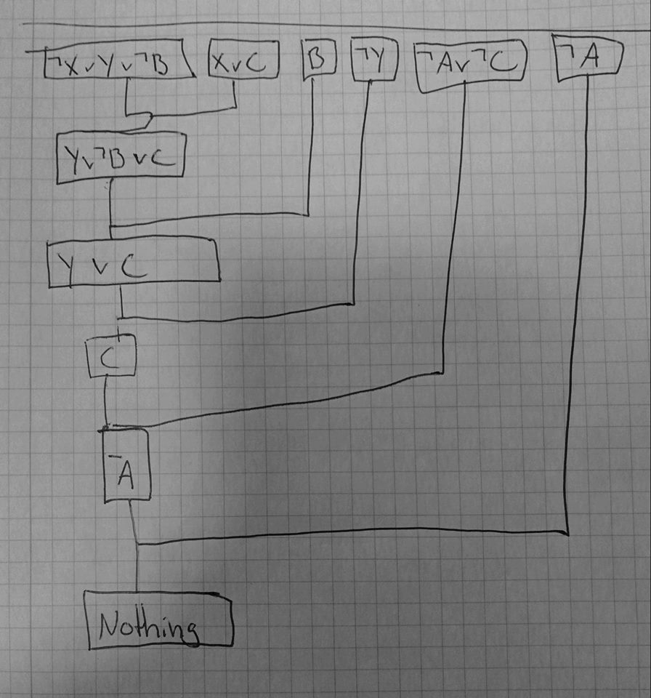

2.3
The task beginning with «consider the following sentence» is 7.18 in my version:
7.18
(Food v Drinks) ⇒Party = A
(¬Party ⇒ ¬Food) = B

Food | Drinks | ¬ B | Party | Food v Drinks | (Food v Drinks) ⇒Party | (¬Party ⇒ ¬Food)
1 | 1 | 0 | 0 | 1 | 0 | 0
1 | 0 | 1 | 0 | 1 | 0 | 0
0 | 1 | 0 | 0 | 1 | 0 | 1
0 | 0 | 1 | 0 | 0 | 1 | 1
1 | 1 | 0 | 1 | 1 | 1 | 1
1 | 0 | 1 | 1 | 1 | 1 | 1
0 | 1 | 0 | 1 | 1 | 1 | 1
0 | 0 | 1 | 1 | 0 | 1 | 1

The sentence is both valid and satisfiable

b)
The first disjuntion on the left of the main implication and the disjunction on the right is equal.
And an implication will only give false if True ⇒ False. The left hand side can only be true if both the disjunctions are True, and considering the first disjunction on the left and the disjunction on the right are equal, the answer will always be True.
Picture below is step by step and answer.
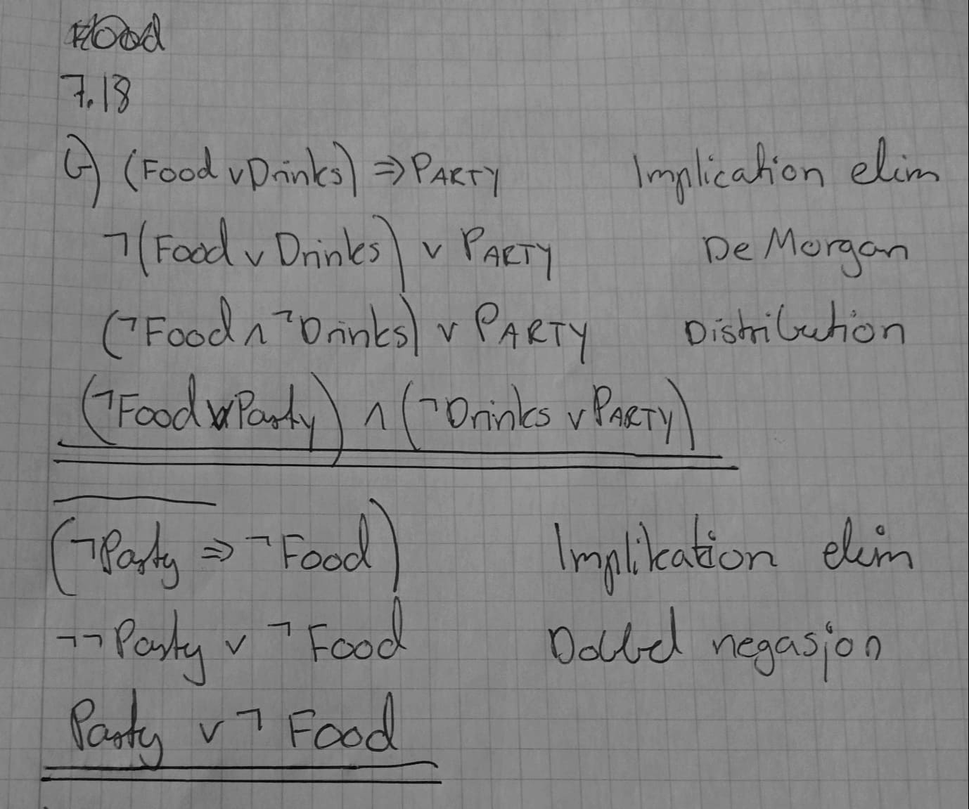

c)

3.1
Christian Bale = CB
George Cloony = GC
Val Kilmer = VK
a)
PlayedCharacter(CB,Batman) ∧ PlayedCharacther(GC, Batman) ∧ PlayedCharacter(VK, Batman)

b)
¬∃x (PlayedCharacter(CB, X) ∧ PlayedCharacter(HeathLedger, X))

c)
∀x (PlayedInMovie(CB,Batman) => Directed(ChristopherNolan,Batman))

d)
∃x (CharacterInMovie(Batman, x) ∧ CharacterInMovie(TheJoker, x))

e)
∃x (PlayedInMovie(Costner, x) ∧ Directed(Costner, x))

f)
¬∃x, ¬∃y (PlayedInMovie(tarantino, x) ∧ PlayedInMovie(GC, x) ∧ (Directed(tarantino, y) ∧ PlayedInMovie(GC, y))

g)
∃x (PlayedInMovie(uma,x) ∧ Directed(Tarantino, x))

3.2
a)
Divisible(x,y)= x / y ⇒ ((z < x) ∧ (x = z * y))

b)
Even(x)= Divisible(x,2)

c)
Odd(x)= Even(x) + 1

d)
Prime(x)= Divisible(x,y) ⇒ x = y

4.1
a)
Philosopher(x) ... Philosopher(Plato) θ = {x / Plato}

b)
Write(Plato, TheRepublic) ... Write(Plato, y) θ = {y / TheRepublic}

c)
Read(x, Metaphysics) ... Read(Peter, y) θ = {x/Peter, y/metaphysics}

d)
Write(x, Fear And Trembling) ... Write(Kierkegaard, x) θ = {none}, x can be to different things.

e)
Write(Kant, CritiqueOfPureReason) ... Write(Author(y), y) θ = {y / CritiqueOfPurePassion}

4.2
a)
∃x∃y: Philosopher(x)∧StudentOf(y,x)
Philosopher(f(x)) ∧ StudentOf(g(y), f(x))

b)
∀y,x: Philosopher(x)∧StudentOf(y,x)→[∃z: Book(z)∧Write(x,z)∧Read(y,z) ]
∀y,x: Philosopher(x)∧StudentOf(y,x)→Book(f(x,y))∧Write(x,f(x,y))∧Read(y,f(x,y))

4.3

